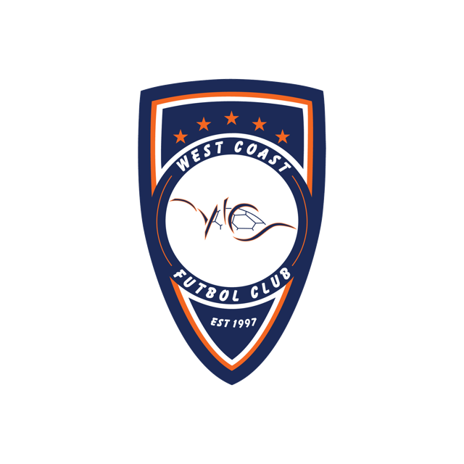
Tryout Player Waiver
In consideration of being allowed to participate in any way in the West Coast Futbol Club practice, competition, or camps, whether involving team or individual events and activities, the undersigned acknowledges, appreciates, and agrees that:
1. The risk to have direct or indirect contact with individuals who have been exposed to and/or diagnosed with one or more communicable diseases, including but not limited to COVID-19 or other medical conditions, diseases, or maladies, and/or any mutation or variation thereof does exist and it is impossible to eliminate the risk that I, or my child, could become infected through contact with or close proximity to an individual with a communicable disease;

2. Contracting the COVID-19 may result in serious health issues for the participant and/or individuals the participant subsequently comes into contact with, and while particular rules, equipment, and personal discipline may reduce the risk of contracting the virus, the risk can never be completely removed;

3. I KNOWINGLY AND FREELY ASSUME ALL SUCH RISKS, both known and unknown, EVEN IF ARISING FROM THE NEGLIGENCE OF THE RELEASEES or others, and assume full responsibility for my participation; and,

4. I willingly agree to comply with the stated and customary terms and conditions for participation. If, however, I observe any unusual, significant hazard during my presence or participation, I will remove myself from participation and bring such hazard to the attention of the nearest official immediately; and,

5. I, for myself and on behalf of my heirs, assigns, personal representatives and next of kin, HEREBY RELEASE AND HOLD HARMLESS West Coast Soccer Club, its officers, officials, agents and/or employees, other participants, sponsoring agencies, directors, sponsors, advertisers, and, if applicable, owners and lessors of the premises used to conduct the event (collectively, the "Releasees"), WITH RESPECT TO ANY AND ALL INJURY, ILLNESS, DISABILITY, DEATH, or loss or damage to person or property, WHETHER ARISING FROM THE NEGLIGENCE OF THE RELEASEES OR OTHERWISE. I HAVE READ THIS RELEASE OF LIABILITY AND ASSUMPTION OF RISK AGREEMENT, FULLY UNDERSTAND ITS TERMS, UNDERSTAND THAT I HAVE GIVEN UP SUBSTANTIAL RIGHTS BY SIGNING IT, AND SIGN IT FREELY AND VOLUNTARILY WITHOUT ANY INDUCEMENT. Parent or legal guardian of each youth player must sign below. FOR PARENT/GUARDIAN OF PARTICIPANT OF MINORITY AGE: This is to certify that I, as parent/legal guardian with legal responsibility for this participant, do consent and agree to his/her release as provided above of all the Releasees, and, for myself, my heirs, assigns and next of kin, I release and agree to indemnify the Releasees from any and all liabilities incident to my minor child's involvement or participation in these programs as provided above, EVEN IF ARISING FROM THEIR NEGLIGENCE.

6. I agree, on behalf of myself and my child, to agree to abide by the terms of this waiver and release, which includes the terms of the attached Code of Conduct.

________________________ ________________________
Parent Name (print) Tryout Player (Child) Name

________________________. ________________________
Parent Signature Tryout Player (Child) Signature
COVID-19 Return to Play Code of Conduct
As a condition of my child’s return to play for the West Coast Futbol Club:

I will abide by the plan requirements set forth by West Coast Futbol Club governing safety and behavior prior to being allowed to participate or enter a facility whether it is a practice, competition, or camp.

I hereby agree and acknowledge that my participation, and that of my child, is completely voluntary and is not required or encouraged by West Coast Futbol Club staff.

I agree to abide by the requirements to divide participants into smaller "stable sports groups" limiting
group participation to 12 (not including coaches). These groups will be consistent and rostered as such.

I will not allow my child to participate in any activities if any member of my household has any of the following new or worsening signs or symptoms of possible COVID-19: Cough - Shortness of breath or difficulty breathing - Chills - Repeated shaking with chills - Muscle pain - Headache – Sore throat - Loss of taste or smell - Diarrhea - Feeling feverish or a measured temperature greater than or equal to 100.0 degrees Fahrenheit- Known close contact with a person who is lab confirmed to have COVID-19. I further agree that if any member of my household experiences these symptoms, I will notify West Coast Futbol Club administrator Michelle Gillett (office@westcoastfc.org)

I will not allow my child to return to sports participation if any individual in my household has diagnosed with COVID-19, until all three of the following criteria are met: i) at least 3 days (72 hours) have passed since recovery (resolution of fever without the use of fever-reducing medications); (ii) the individual has improvement in symptoms (e.g., cough, shortness of breath); and (iii) at least 10 days have passed since symptoms first appeared; or in the case of an individual who has symptoms that could be COVID-19 and does not get evaluated by a medical professional or tested for COVID-19, the individual is assumed to have COVID-19, and the individual may not return until they have completed the same three-step criteria listed above; or if the individual has symptoms that could be COVID-19 and wants to return to work before completing the above self-isolation period, the individual must obtain a medical professional's note clearing the individual for return based on an alternative diagnosis.

I agree to, whenever possible, drop off kids and pick them up from practice while staying inside my vehicle. If I choose to stay and observe the practice, they may do so from pre-designated areas, while keeping proper distancing from athletes and other parents.

I agree to adhere to West Coast Futbol Club’s plan for drop off and pick up that adheres to social distancing guidelines and will follow any parking direction and route direction that is provided at the practice site.

I agree to instruct my child on the club’s recommended guidelines for physical contact, which initially involve the prohibition of hugs, high-fives, etc.

I agree to ensure that my child has washed or sanitized their hands before entering the facility.

I agree to handle and care for their own equipment such as cleats, water bottles, pennies, soccer balls, etc. Staff or volunteers will not be allowed to handle.

I agree to abide by the rules put in place by West Coast Futbol Club to regulate practice or drill times to control the number of youth participants at the facility at one time to ensure social distancing between stable groups.

I agree to use all due care to not arrive at the facility until the previous group has completely left the field on which practice is to take place.

I agree to follow any instruction from WCFC staff regarding health and safety protocols, as they are amended from day to day.

